Week 1 – 0
---coding-C-language features-optional.
REG NO.:241801291
NAME : Tarrun.B
Q1) This is a simple challenge to help you practice printing to stdout. We're starting out by printing the most famous computing phrase of all time! In the editor below, use either printf or cout to print the string Hello, World! to stdout. Input Format You do not need to read any input in this challenge. Output Format Print Hello, World! to stdout. Sample Output Hello, World! Answer: (penalty regime: 0 %)

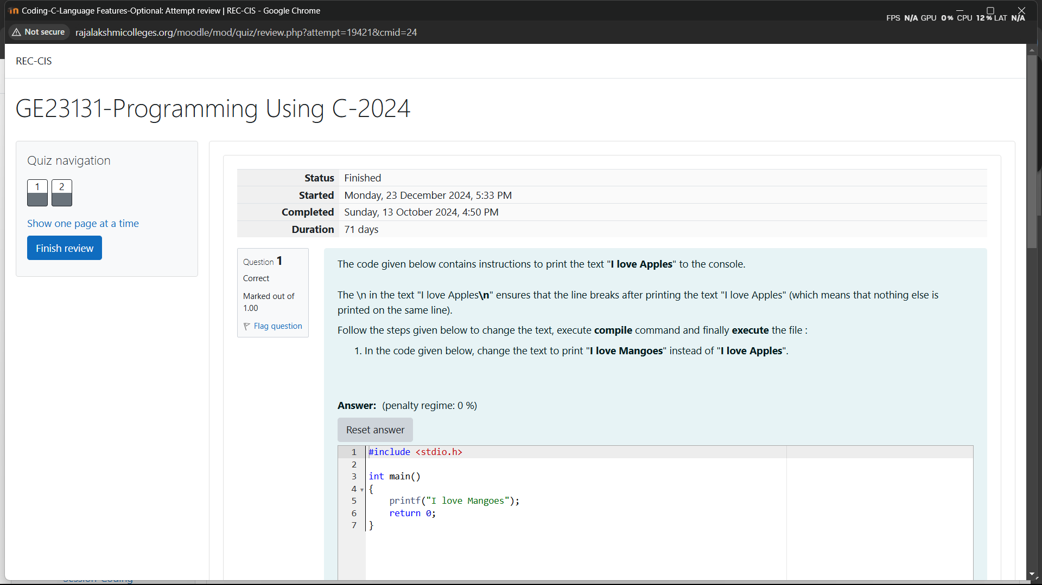
OUTPUT
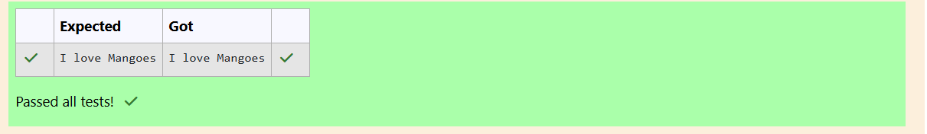

WEEK 1-0
CODING C LANGUAGE FEATURES OPTIONAL
REG NO.:241801291
NAME: Tarrun.B
Q1) This is a simple challenge to help you practice printing to stdout. We're starting out by printing the most famous computing phrase of all time! In the editor below, use either printf or cout to print the string Hello, World! to stdout. Input Format You do not need to read any input in this challenge. Output Format Print Hello, World! to stdout. Sample Output Hello, World! Answer: (penalty regime: 0 %)
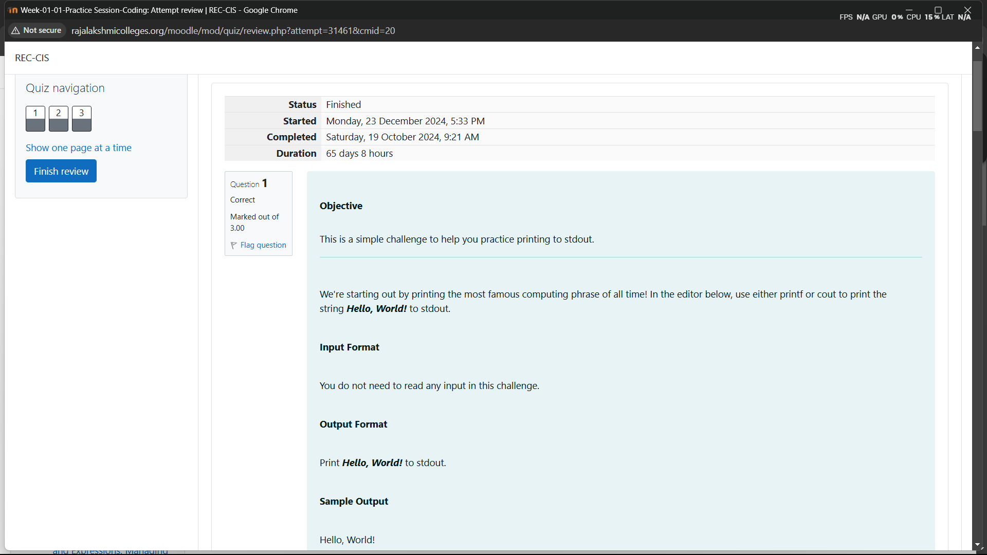
OUTPUT
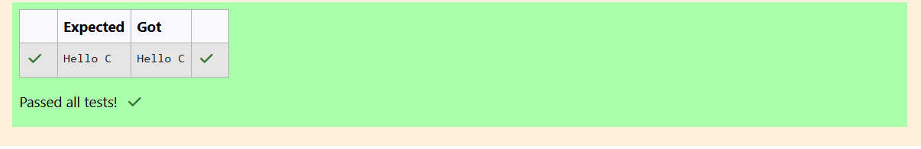

WEEK 01-01-PRACTICE SESSION CODING
ROLL NO: 2418012
NAME: Shyam Ganesh D
Q1)
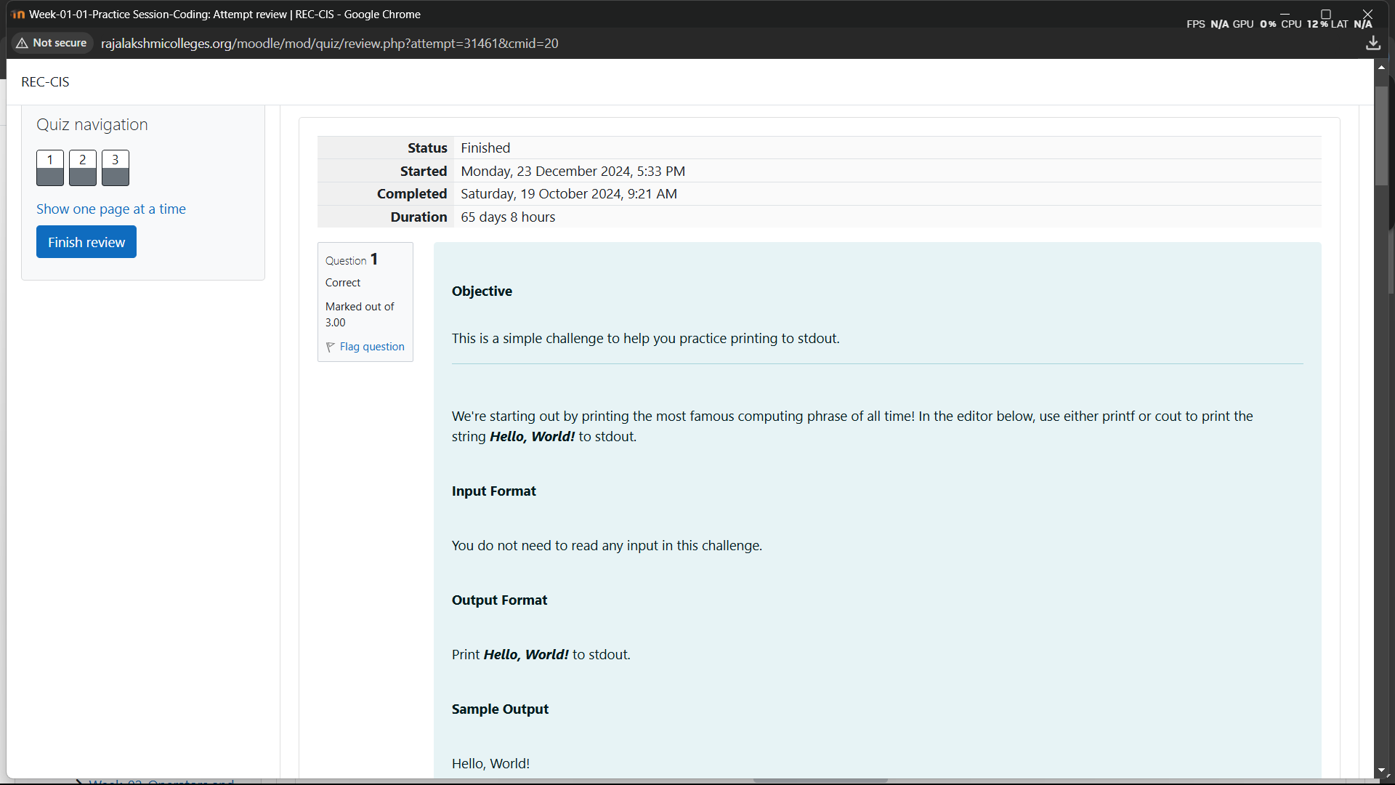
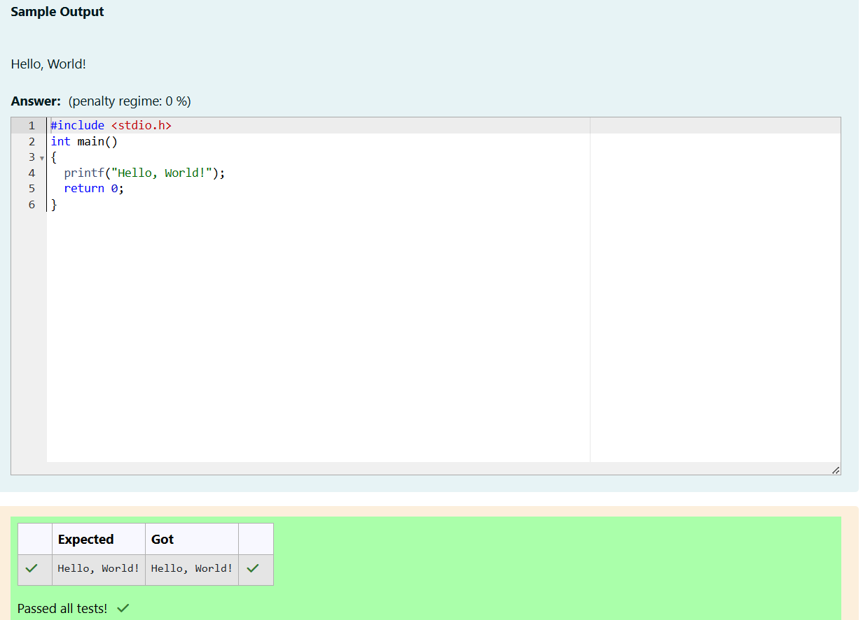
Q2)
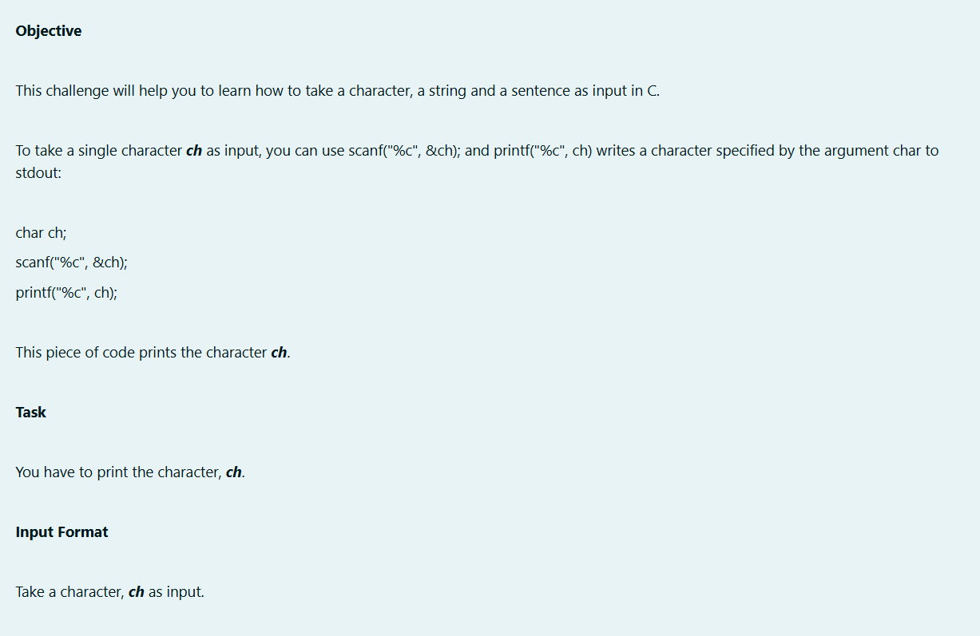
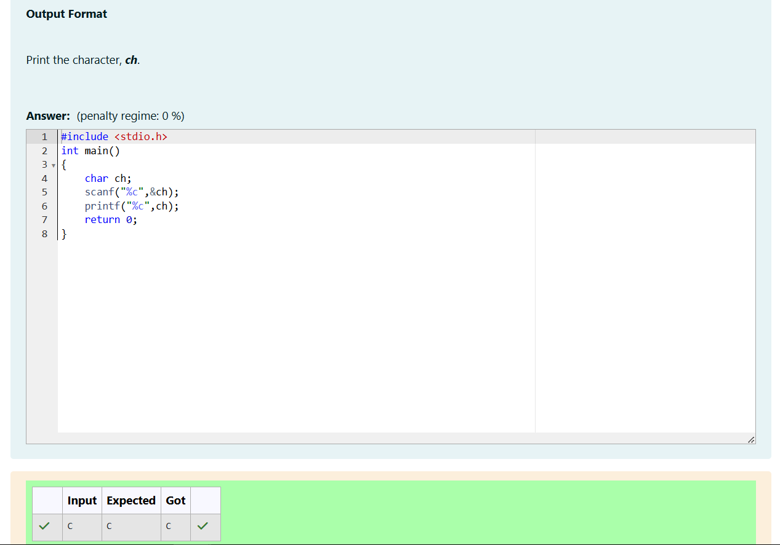
Q3)
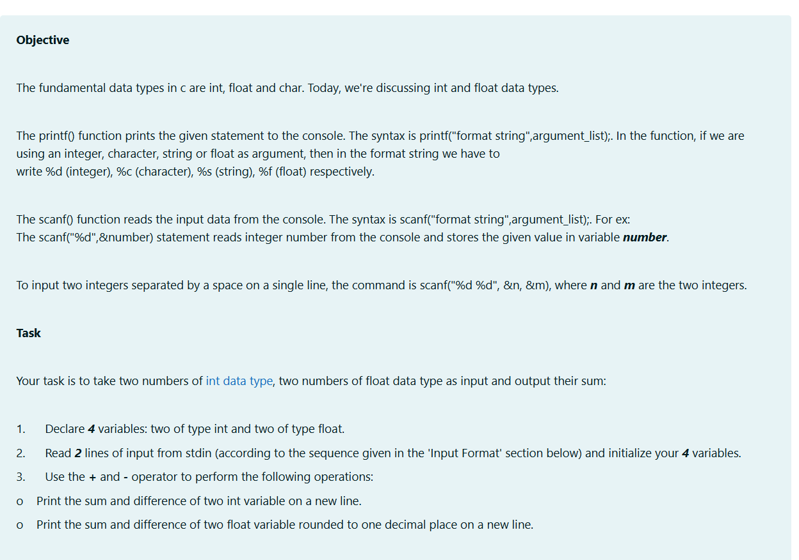
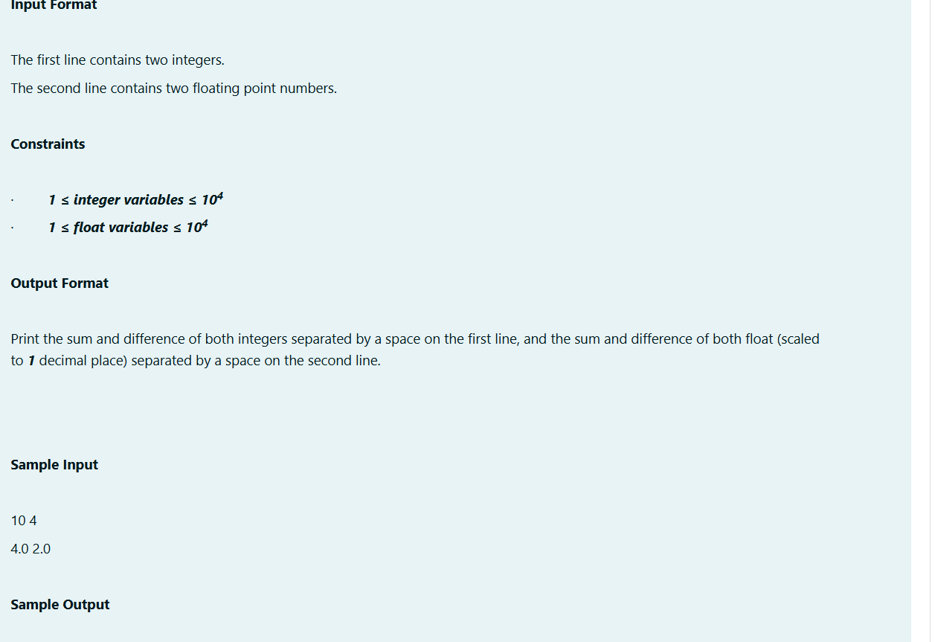

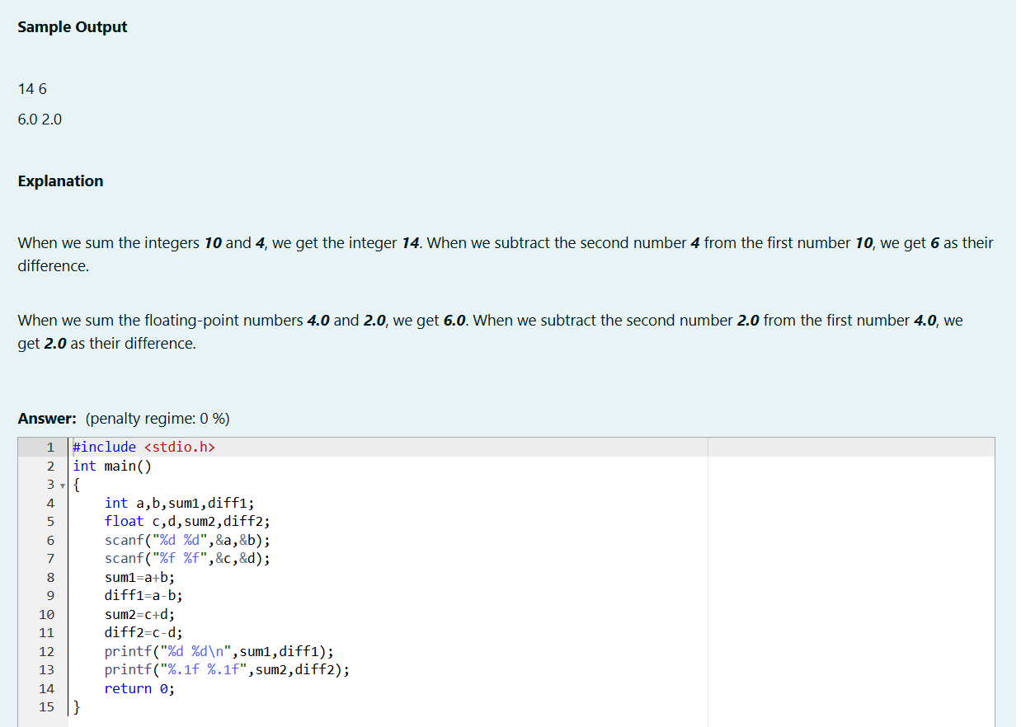
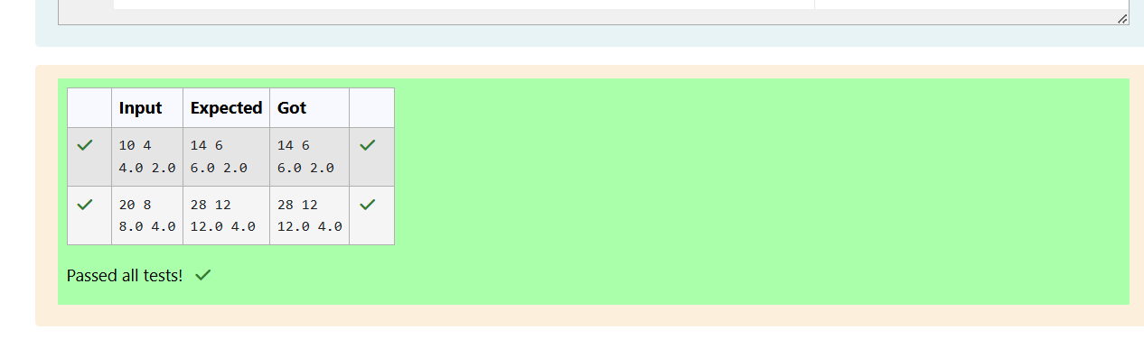

WEEK 01-02 PRACTICE SESSION CODING
ROLL NO.:241801291
NAME: Tarrun.B
Q1)
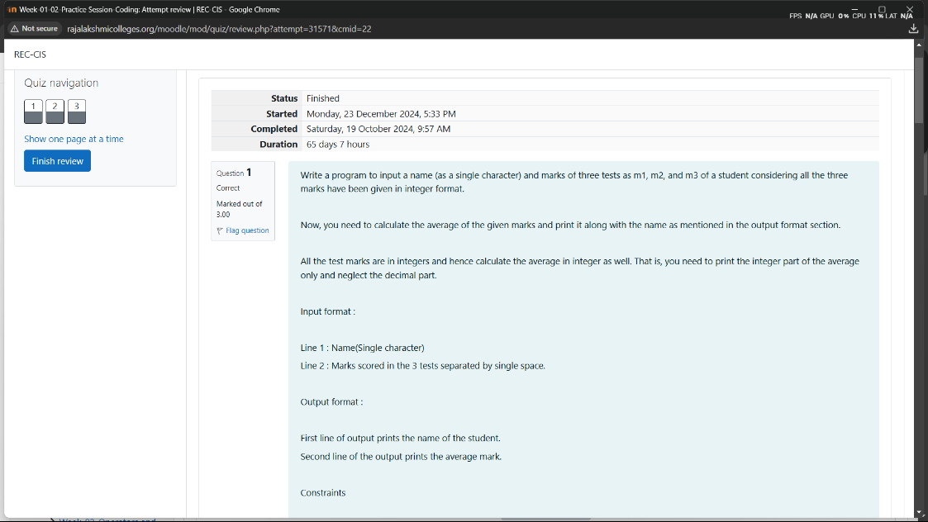
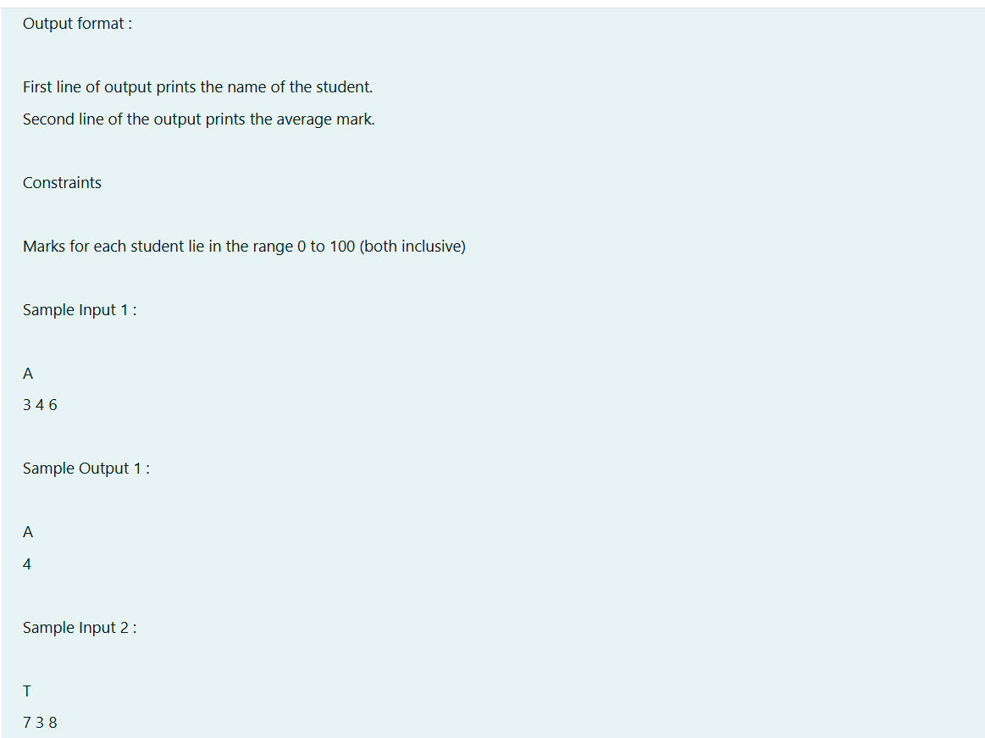

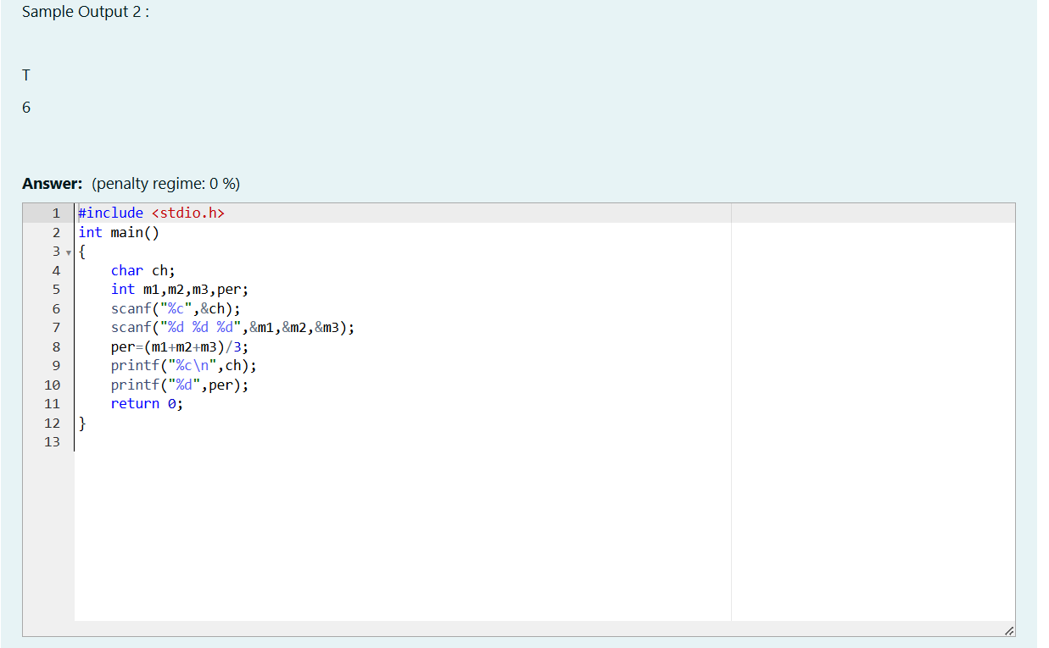
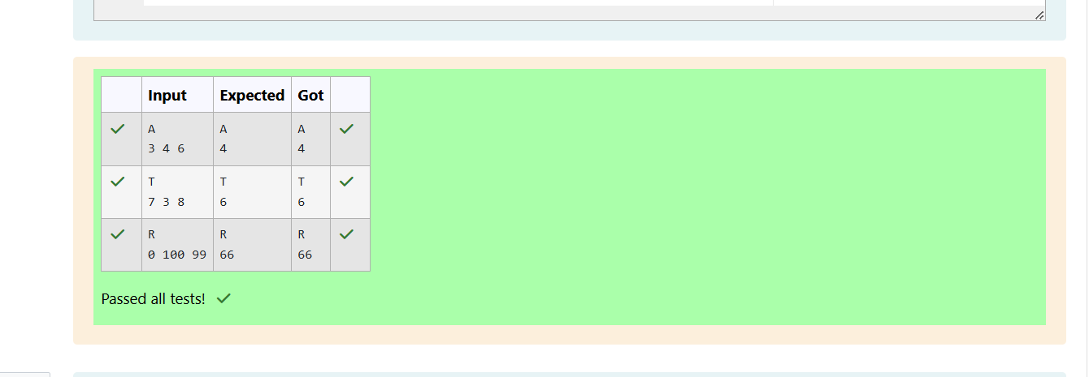

Q2)
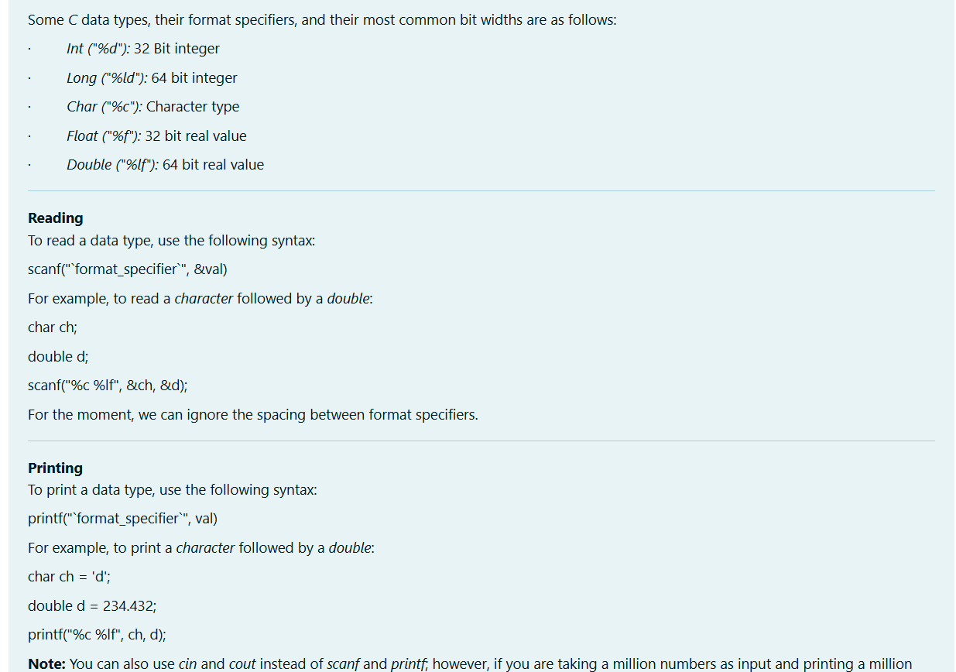
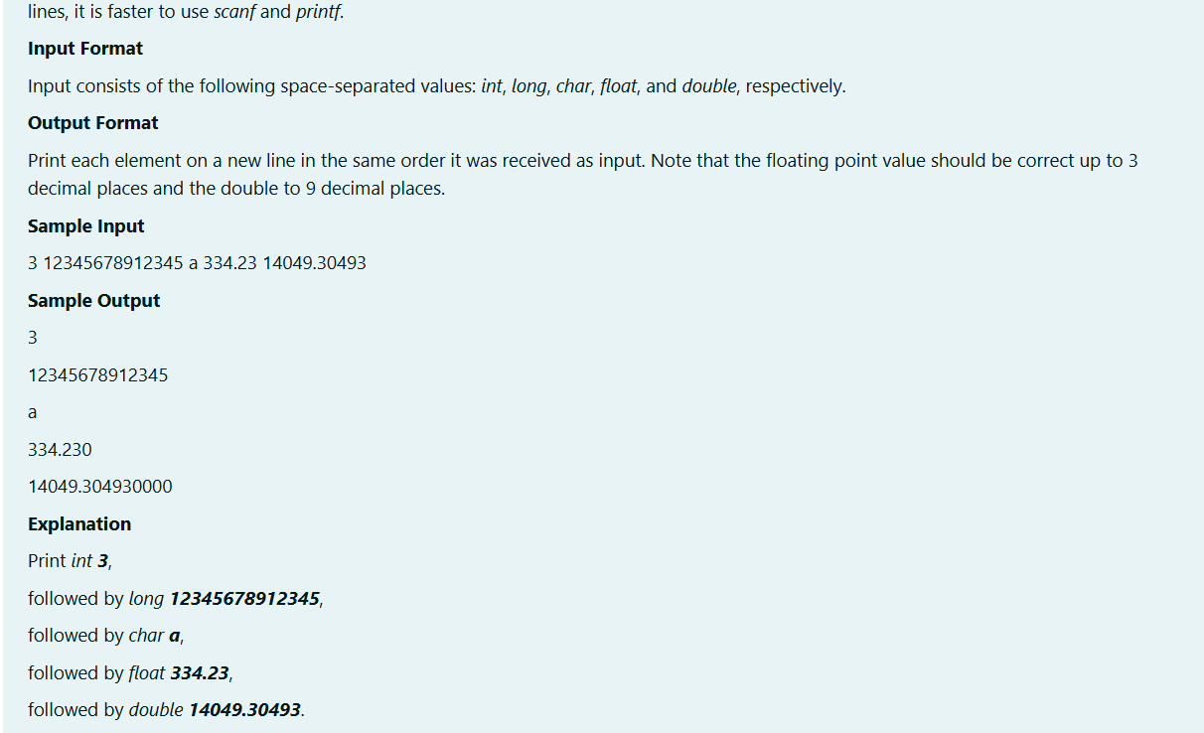
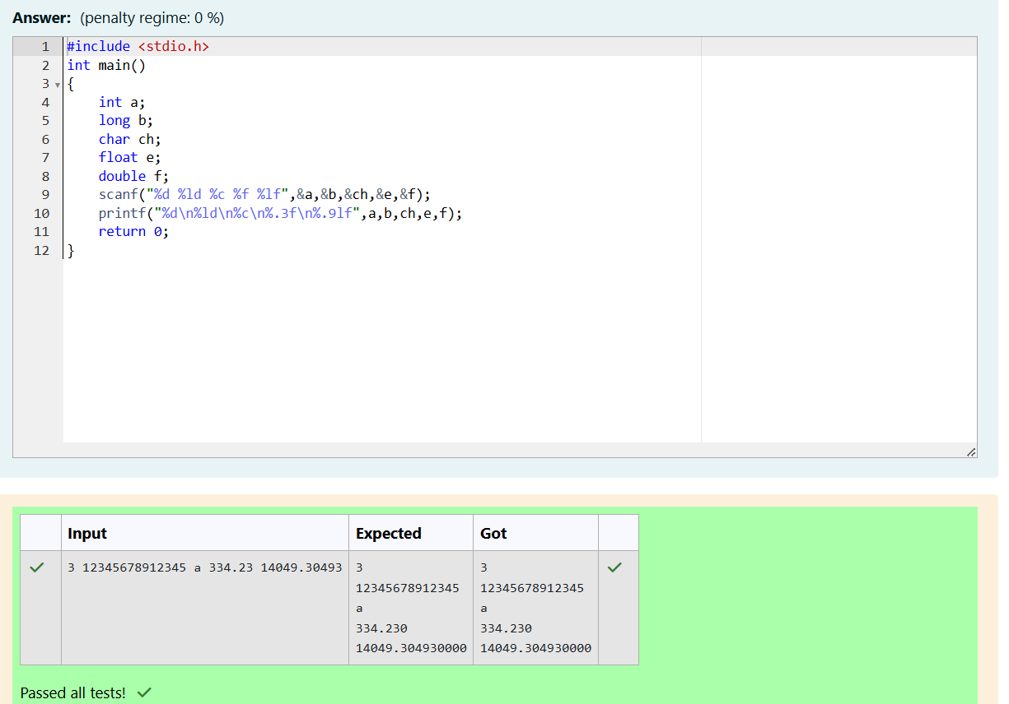
Q3)
